**Architectural Diagram of Fleet Management Application:**

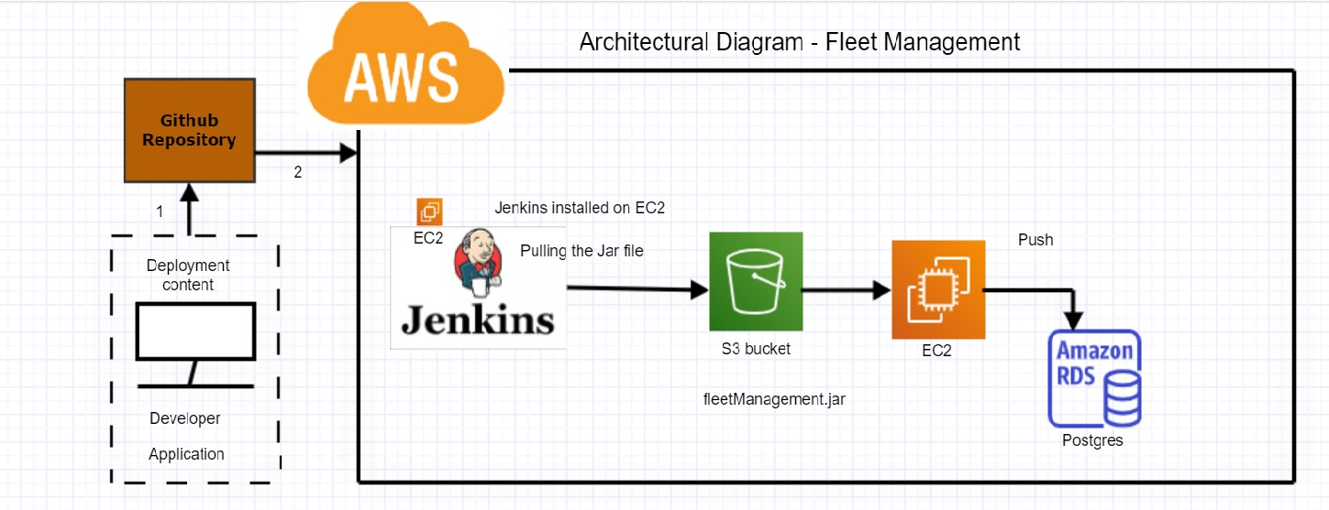

**EC2 Instance**:

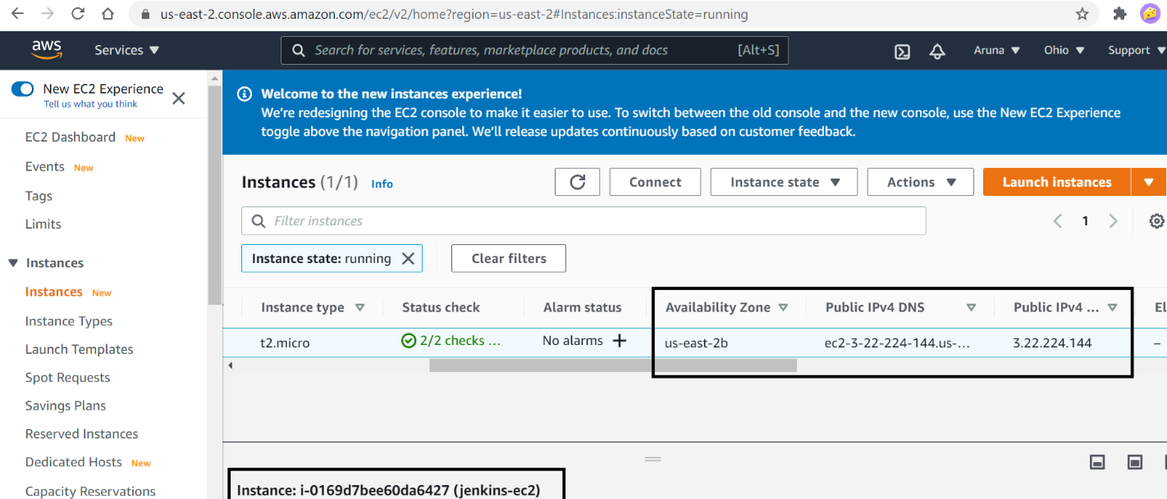

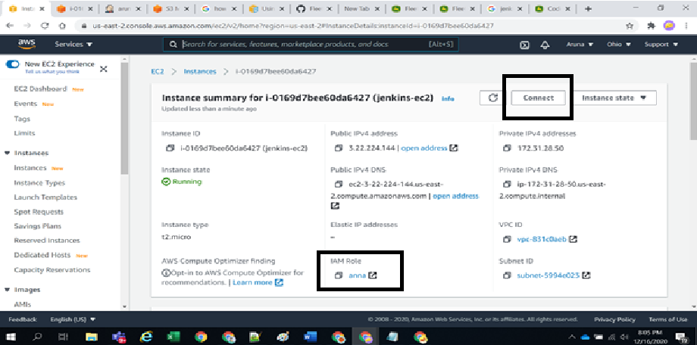

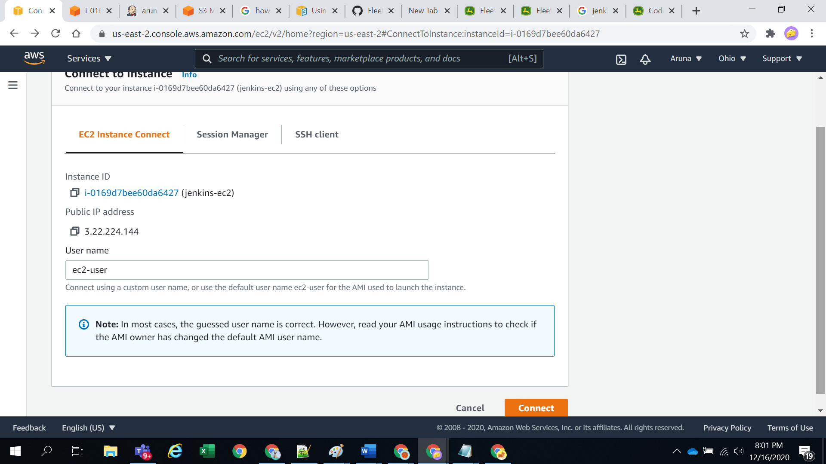

**RDS Instance:**

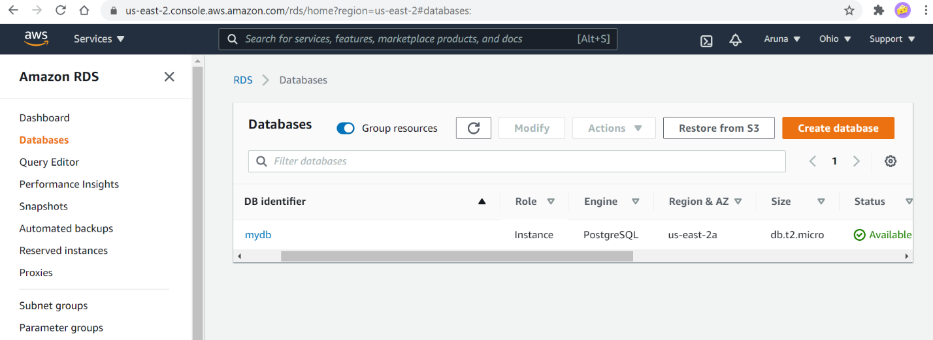

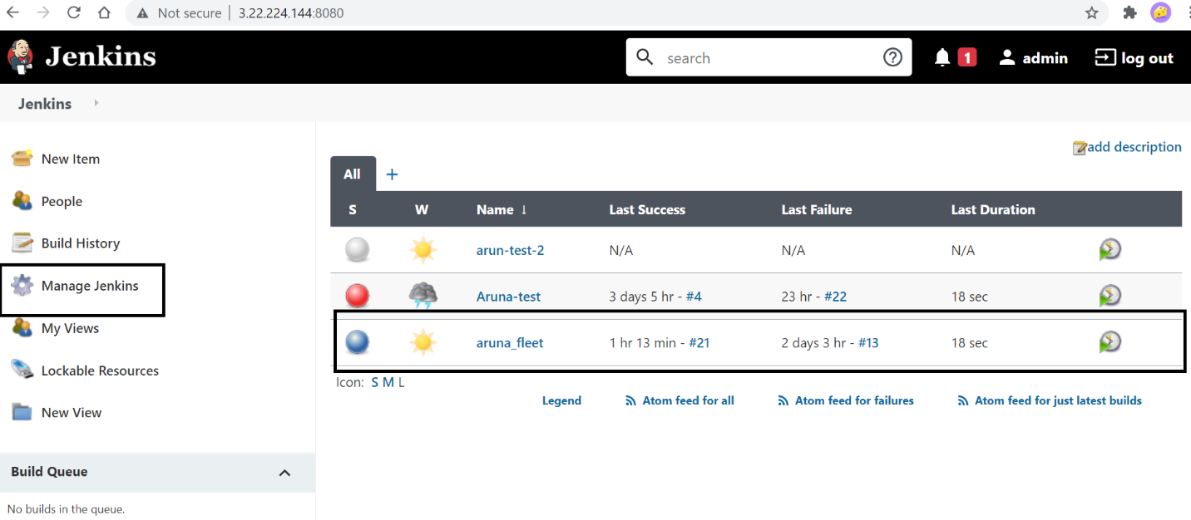

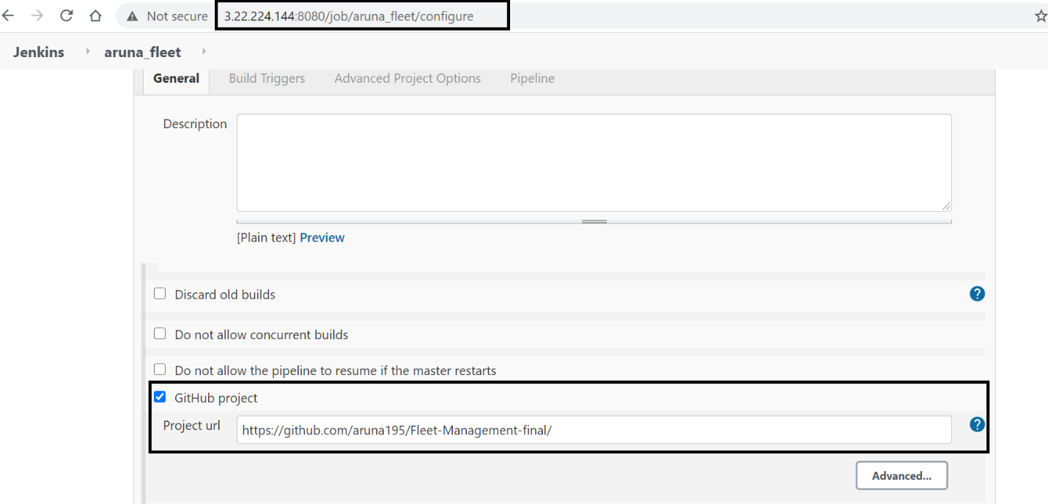

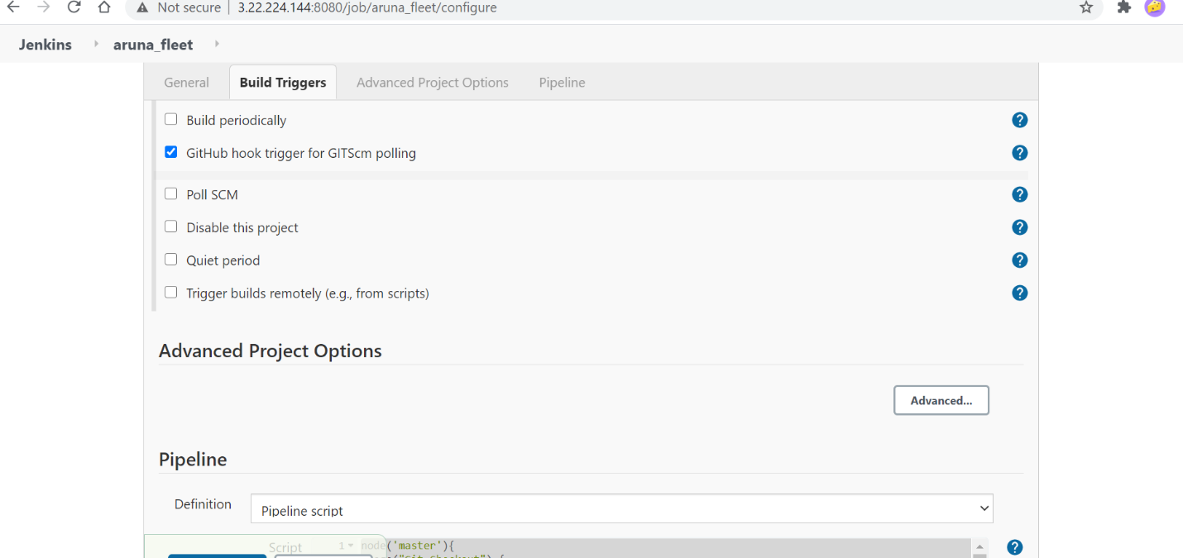

node('master'){

stage("Git Checkout") {

checkout(

[

$class: 'GitSCM',

branches: [[name: "master"]],

doGenerateSubmoduleConfigurations: false,

extensions: [], submoduleCfg: [],

userRemoteConfigs: [

[

url: 'https://github.com/aruna195/Fleet-Management-final']]])

}

stage("Build") {

sh 'mvn clean install'

}

stage("AWS S3 Upload") {

withAWS(credentials:'aruna1') {

sh 'aws s3 cp ${WORKSPACE}/target/fleetManagement-0.0.1-SNAPSHOT.jar s3://arunas3bucket/fleetManagement.jar'

}

}

}

**Build Now:**

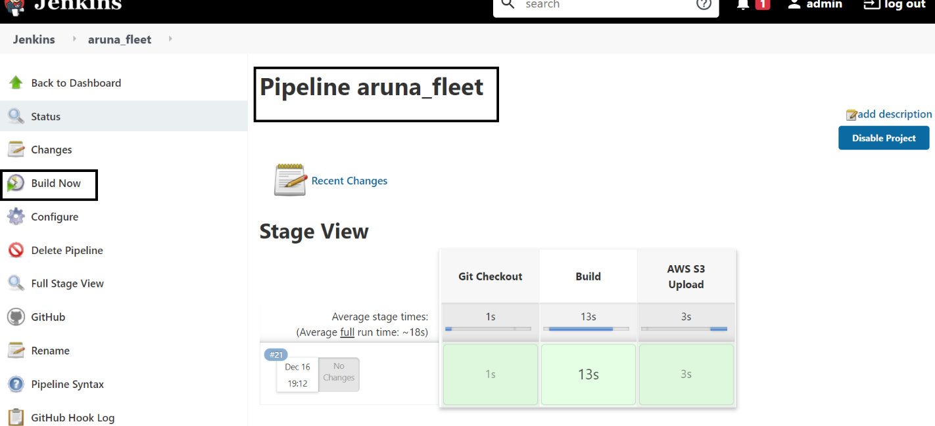

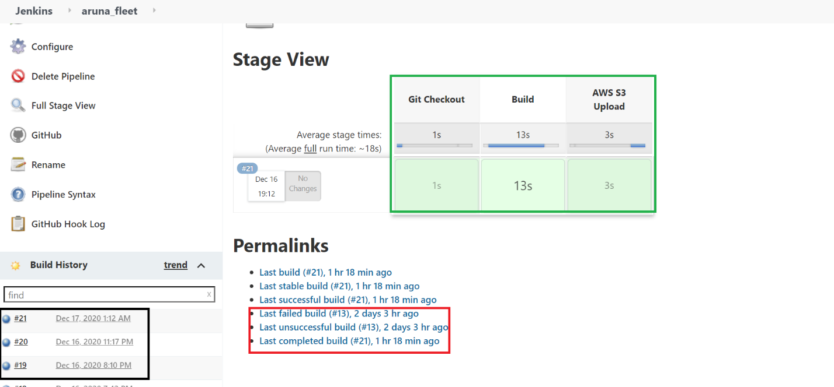

S3 Bucket